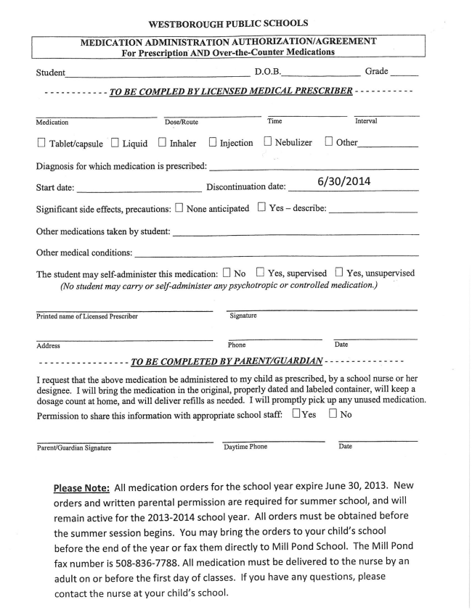
WESTBOROUGH PUBLIC SCHOOLS
MEDICATION ADMINISTRATION AUTHORIZATION/AGREEMENT For Prescription AND Over-the-Counter Medications
Student D.O.B. Grade
- - - - - - - - - - - - TO BE COMPLED BYLICENSED MEDICAL PRESCRIBER - - - - - - - - -
Medication DQsclRoute Time Interval
U Tablet/capsule I Liquid [I Inhaler D Injection D Ncbulizer D Other
Diagnosis for which medication is prescribed:
Start date: Discontinuation date: 6/30/2014
Significant side effects, precautions: None anticipated D Yes — describe:
Other medications taken by student:
Other medical conditions:
The student may self-administer this medication: No B Yes, supervised D Yes, unsupervised (No student may carry or self—administer any psychotropic or controlled medication.)
Printed name of Licensed Prescriber Signature
Address Phone Date
-----------------TOBECOMPLETEDBYPARENT/GUARDIAN-----------~--
I request that the above medication be administered to my child as prescribed, by a school nurse or her designee. I will bring the medication in the original, properly dated and labeled container, will keep a dosage count at home, and will deliver refills as needed. I Will promptly pick up any unused medication.
Permission to share this information with appropriate school staff: UYes D No
Parent/Guardian Signature Daytime Phone Date
Please Note: All medication orders for the school year expire June 30, 2013. New orders and written parental permission are required for summer school, and will remain active for the 2013—2014 school year. All orders must be obtained before the summer session begins. You may bring the orders to your child’s school before the end of the year or fax them directly to Mill Pond School. The Mill Pond fax number is 508-836'7788. All medication must be delivered to the nurse by an
adult on or before the first day of classes. If you have any questions, please
contact the nurse at your child's school.

